|  |  |  |  |  |  |  |  |  |
| --- | --- | --- | --- | --- | --- | --- | --- | --- |
|  | | **Minia University**  **Faculty of Engineering**  **Computers and Systems Engineering Department** |  |  | **جامعة المنيا**  **كلية الهندسة**  **قسم هندسة الحاسبات والنظم** | |  | |
| ***Title:*** | **PID Tuning and Simulation for Mag. Lev. System (Student Task)** | | | | | | | |
| ***Full Name:* ابرام صموئيل ابراهيم** | | | | | | ***Date:* /4/2023** | |

**Answer the following questions:**

1. Design the PID controller for MagLev system using ***sisotool*** then plot the step response and the control action of the controller. (Write the controller parameters and take screenshots for each step)

* Controller Parameters:  
  Kp=1.1543, Ki = 2.1241, Kd = 0.0368, Tf = 0.000266

1. Add an integrator   
   Graphical user interface

   Description automatically generated
2. Add two real zeros  
   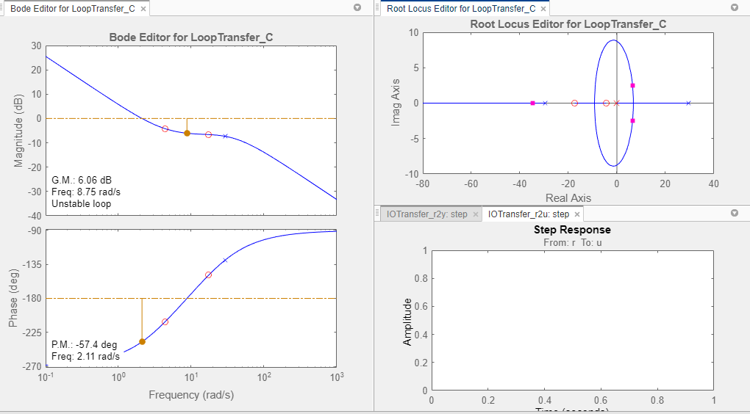
3. PID tuning  
   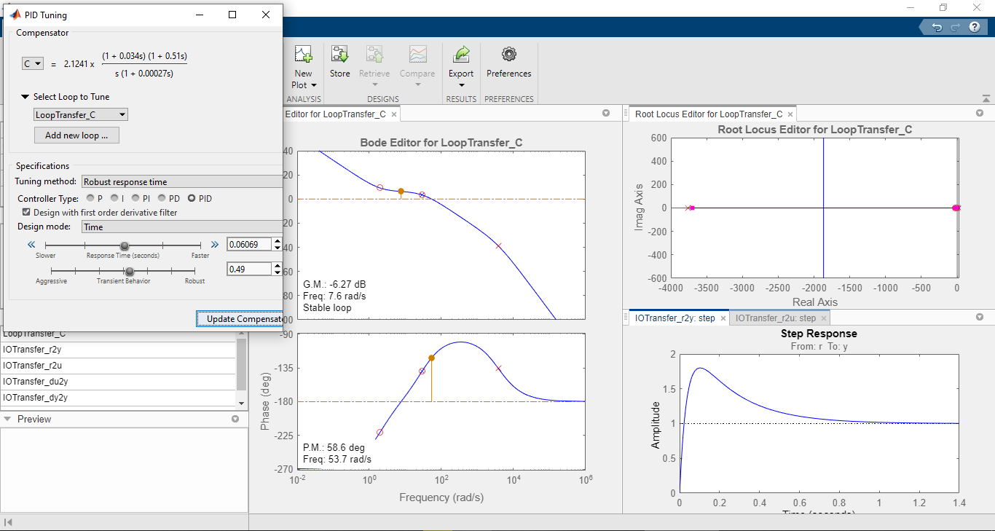
4. Export compensator (PID)  
   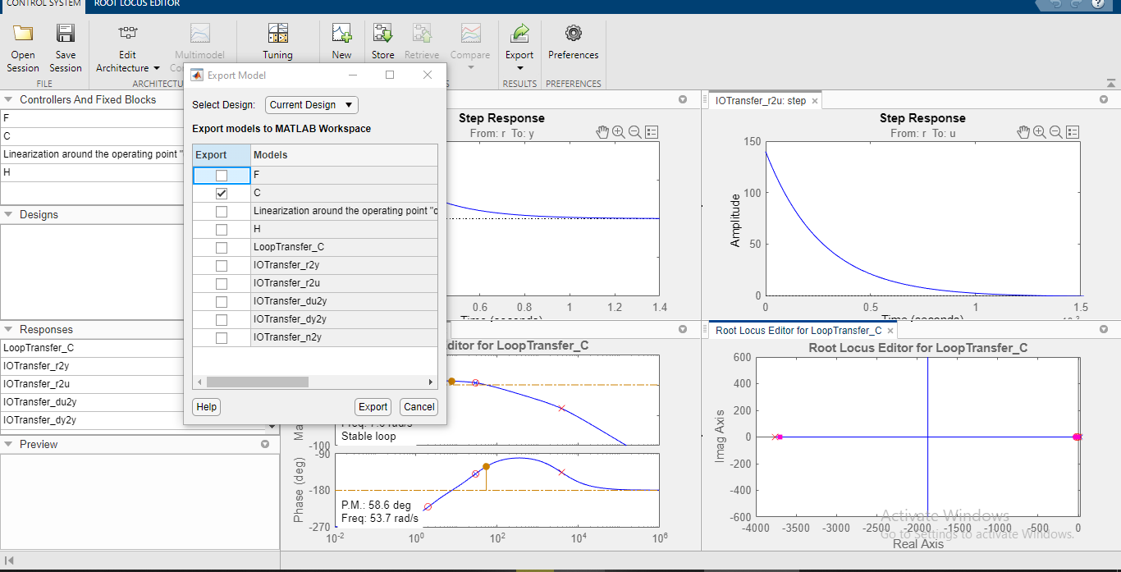
5. Parameters (Kp,Ki,Kd) using sisotool   
   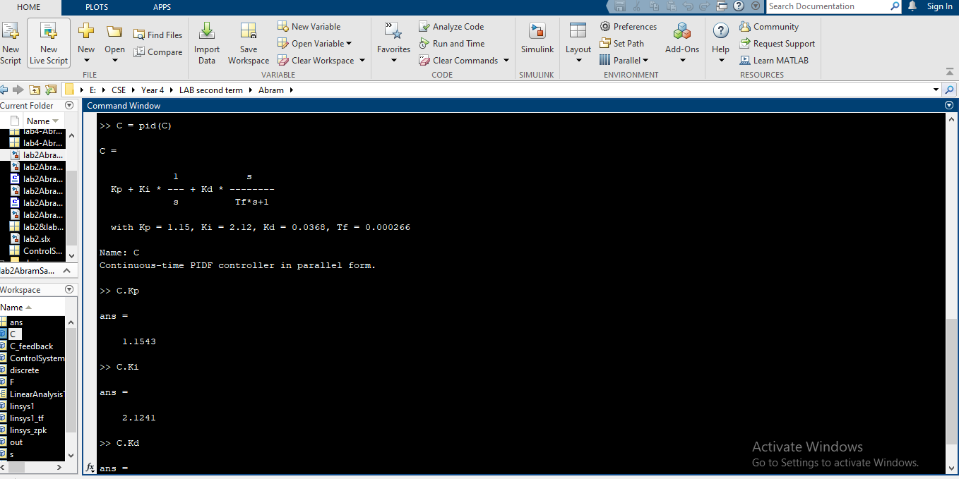

1. Design the PID controller for MagLev system using ***pidTuner*** tool then plot the step response and the control action of the controller. (Write the controller parameters and take screenshots for each step)

* Controller Parameters :-  
  Kp = 1.338 , Ki=9.6577 ,Kd= 0.036415 , Tf= 0.011726

1. pidTuner toolbox  
   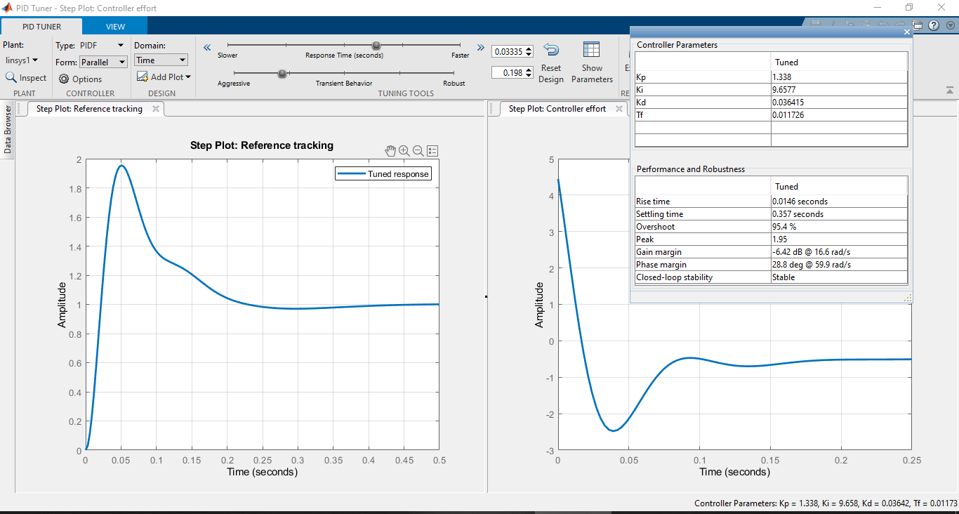
2. MagLev PID  
   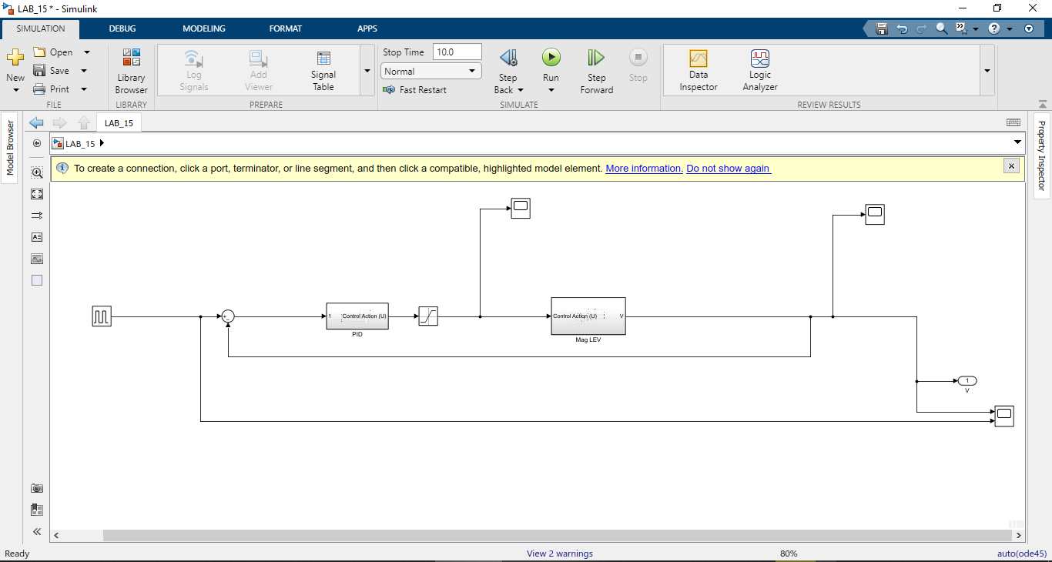
3. PID compensator  
   Diagram

   Description automatically generated
4. Control action after saturation  
   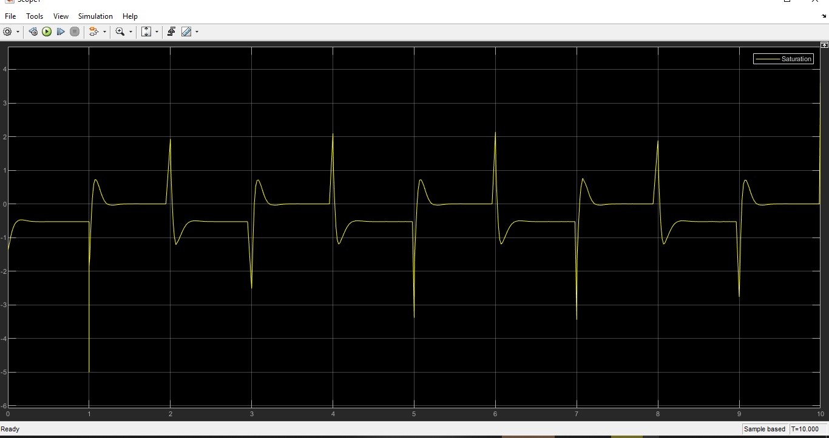
5. MagLev output   
   A picture containing text

   Description automatically generated
6. MagLev vs. Continuous pulse generator

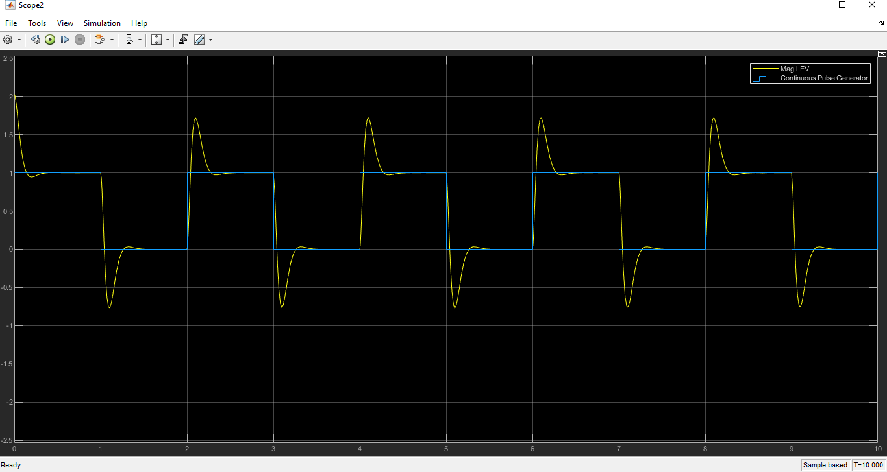

1. Plot the step response for the best controller and write the information of the response.

Rise time = 0.0173 sec.  
Overshoot = 73.4%  
Serrling time = 1.04 sec.  
Final value = 1

1. Repeat (3) for the bode diagram.

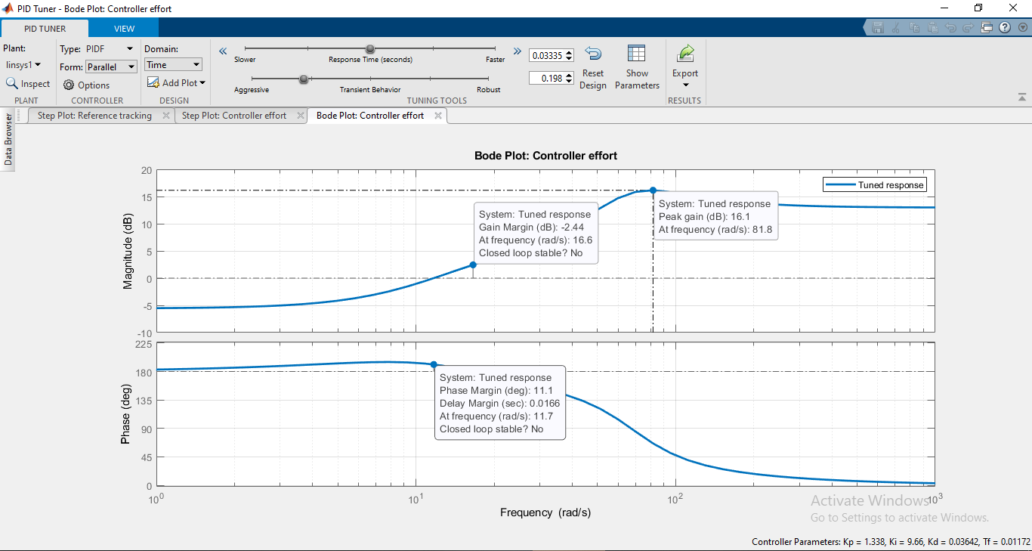

Phase Margin = 11.1 deg  
 Gain margin = -2.44 dB